Android NDK Standalone Toolchain
G++
- Select Toolchain
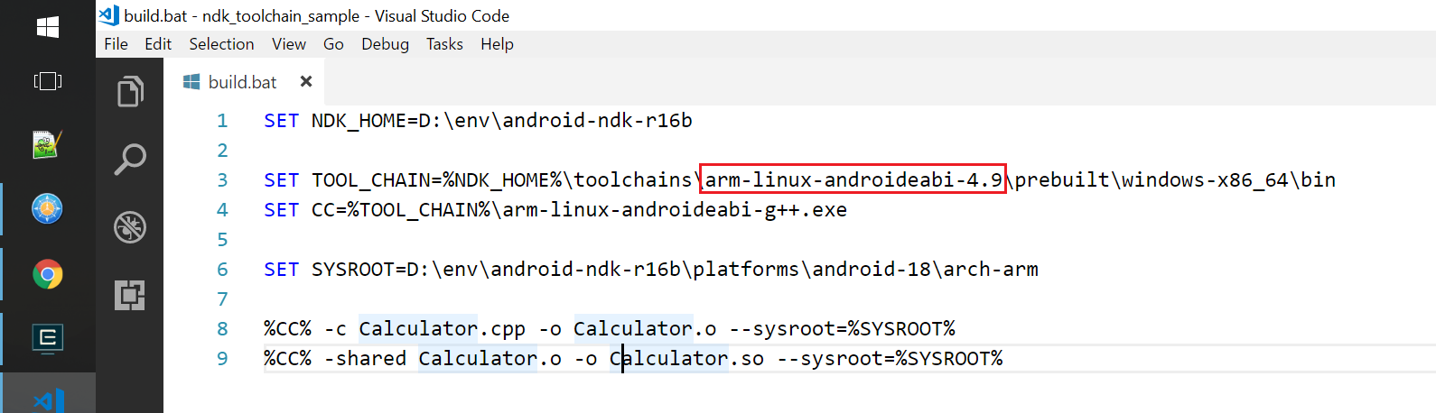

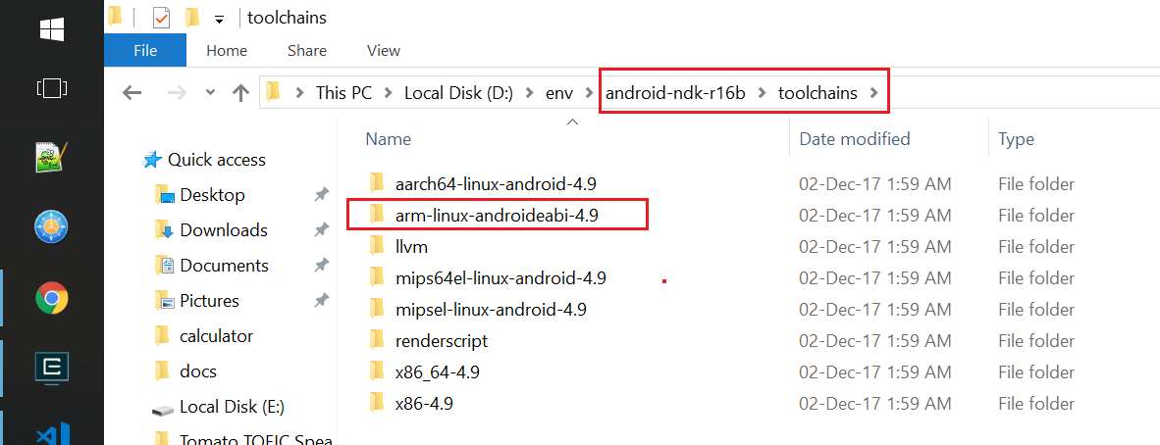

- Select Compile Tool
Set CC=arm-linux-androideabi-g++.exe

- Select Sysroot
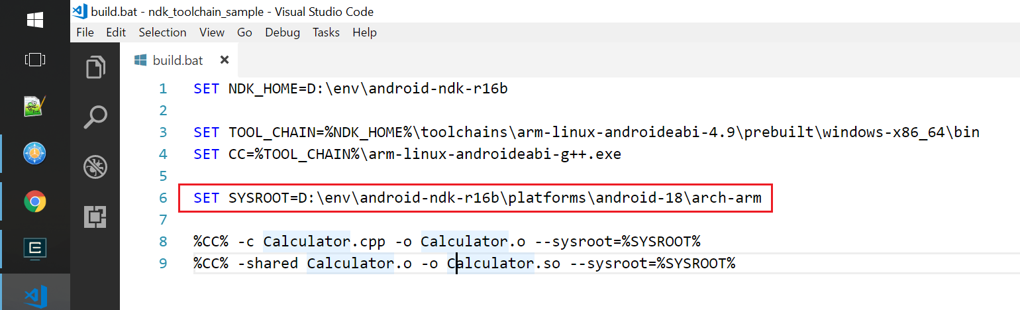

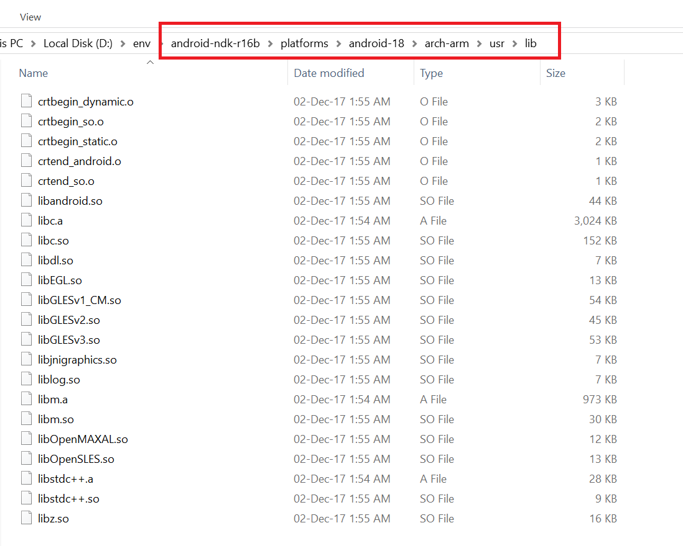

- Build object file
arm-linux-androideabi-g++ -c Calculator.cpp -o Calculator.o --sysroot=android-18\arch-arm

- Create shared library
arm-linux-androideabi-g++ -shared Calculator.o -o Calculator.so --sysroot=android-18\arch-arm

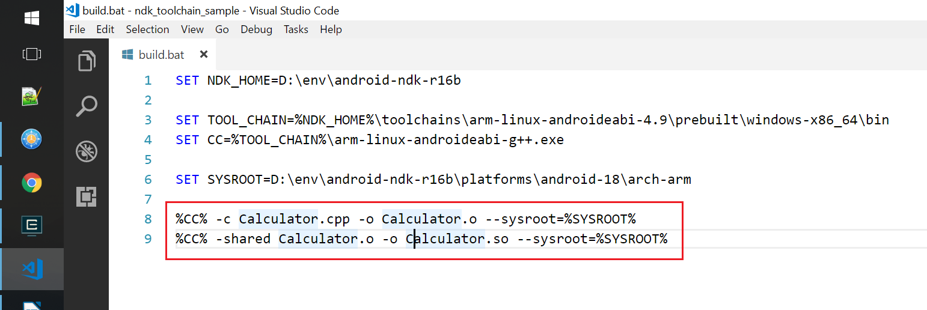

- Result
